(Approx. 1039 words)

Ventoy
By Dick Maybach, Brookdale Computer User Group
www.bcug.com
n2nd (at) att.net

Some years ago, Linux live CD-ROMs appeared. When these were mounted on a PC, it would boot directly from them and not require access to the hard disk. Later we saw live DVDs and then live USB memory sticks and SD cards. A limitation was that each distribution used an entire storage device. Ventoy, https://www.ventoy.net/en/index.html, which is available for Windows and Linux, removes this restriction. In this article, I’ll cover what Ventoy does, how to set it up, and how you can use it.

Figure 1 shows the screen you see after booting from a Ventoy memory stick that contains three Linux distributions, the general-purpose Knoppix, the repair tool PartedMagic, and the high-security Tails Linux. You then select the one you want to run.

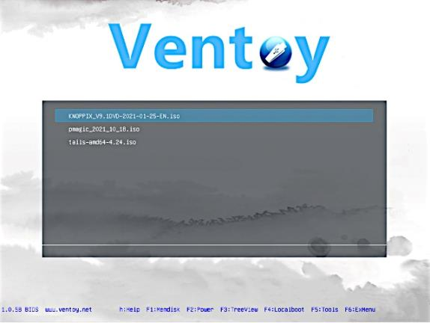
Figure 1. Ventoy Boot Menu.

Begin by downloading a program to format storage devices from the Ventoy website. It’s in the form of an archive; just unpack it and go to the resulting directory. Once there, mount the memory device, and run the program Ventoy2Disk.exe (in Windows) or VentoyGUI.x86_64 (in Linux) to see the screen in Figure 2. (There are alternate versions for special situations; visit the Ventoy website.) Next, you select a device and then choose either Install (to create a new Ventoy device) or Update (to update an existing one). However, you will have more versatility if, before you click Install, you select the Option button at the top left of Figure 2, then select Partition Configuration, then Preserve some space at the end of the disk, and finally enter the amount. (For a 32-Gbyte medium, I choose 1 Gbyte; see below for the reason. You, of course, may prefer a different configuration.)

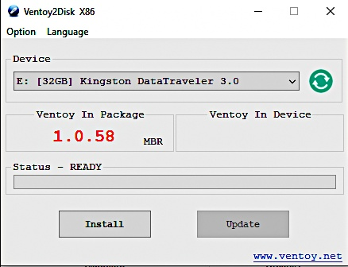
Figure 2. Ventoy2Disk Window.

You’re not entirely done. The device now has two partitions, a large empty one with an exFAT format (labeled “Ventoy”) and a small one with a fat16 format (labeled “VTOYEFI”) that contains the Ventoy boot program. There is also (if you took the advice above) unformatted space at the end. Reformat the Ventoy partition to NTFS and format the space at the end to NTFS with the label “Persist” (more about this later). You’ll copy the live ISO files into the Ventoy partition. Since both Windows and Linux can access NTFS, the device will be usable on both. The result is Figure 3, and the memory stick or SD card is ready to use.

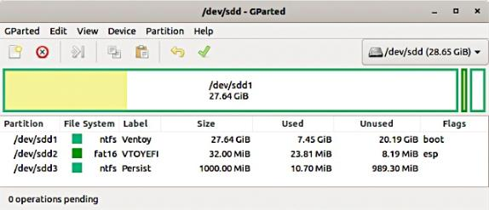
Figure 3. USB Memory Stick After Ventoy Is Installed.

When you mount the device as a memory stick (that is, you don’t boot from it), you’ll see either two or three partitions. (Linux hides the middle one; Windows shows it.) As you can see, a 32-Gbyte stick with the three Linux distributions of Figure 1 has over 20 Gbytes available for transferring files. Figure 4 shows the files in the Ventoy partition that resulted in Figure 1. I created the Scratch directory to separate files transferred from the ISO images.

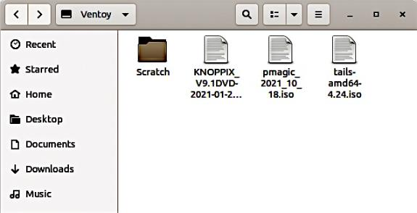
Figure 4. Files on a Ventoy USB Stick.

When you boot from the stick, neither the Ventoy partition nor VTOYEFI is available, but the live distributions can use partition three. This is because software booted from a live medium normally has only RAM for storage and forgets everything when it’s shut down. However, if you create a third partition mentioned above, you can copy data that will persist after a shut-down, hence a label. This partition appears as a separate drive on the file manager when running a live distribution. It is also accessible when the medium is mounted on a PC, so you can transfer data to and from it.

Old PCs (those booting using a BIOS) will boot from a USB memory stick without complaining. However, if yours has a UEFI, you will probably have to change some BIOS settings. See https://www.digitalcitizen.life/boot-your-windows-10-pc-usb-flash-drive/ or my article UEFI Configuration for Booting Live Media in the March 2020 BCUG Bytes, available at http://www.bcug.com/.

How might you use the result? I carry a 32-GByte USB memory stick in my key case for transferring files. I’ve installed Ventoy on it with the three operating systems shown in Figure 1:
- Knoppix, http://knoppix.net/ – a general-purpose Linux distribution optimized for use on live USBs,
- PartedMagic, https://partedmagic.com/ – a PC repair tool, and
- Tails Linux, https://tails.boum.org/ – an enhanced-security Linux distribution.

Knoppix lets me use my preferred OS, Linux, on almost any PC, regardless of whether the software on its hard disk is damaged or infected with malware. PartedMagic will help me repair a PC. And Tails will let me safely communicate with my bank or credit card company from anywhere. None makes any changes to data on the PC’s hard disk unless I specifically do that. Figures 5, 6, and 7 show the home pages of these quite different distributions.

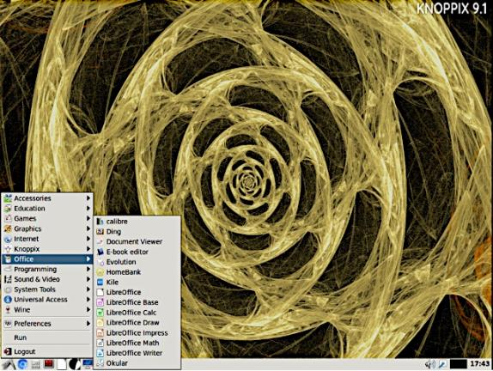
Figure 5. Knoppix Home Screen, Showing Its Office Application Menu.

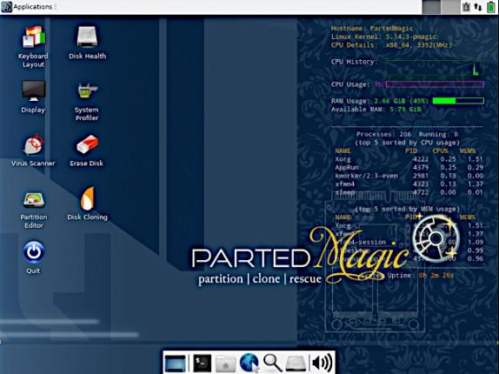
Figure 6. PartedMagic Home Screen.

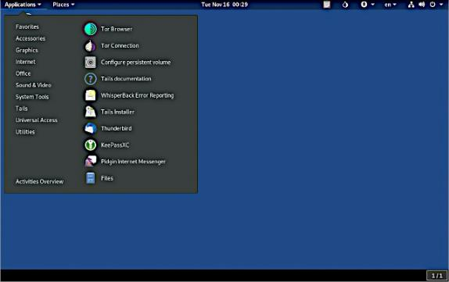
Figure 7. Tails Home Page, Showing Its Favorites Menu.

All three distributions (Knoppix, PartedMagic, and Tails) have the program KeePassXC, https://keepassxc.org/, which I use to store sensitive data, such as user names, passwords, and PINs, in an encrypted database. I keep this in the Persist partition, which makes the data available if I need it and keeps it secure. I also exported my contact list to a spreadsheet stored in Persist. All three distributions include LibreOffice, https://www.libreoffice.org/, which can access this spreadsheet. Finally, all three have the encryption program GNU Privacy Guard, https://gnupg.org/, so I can safely store sensitive data on the medium. As you can see in Figure 8, the same key case also has a real Swiss Army Knife; as a result, I’m prepared for anything from disk crashes to wilderness survival.

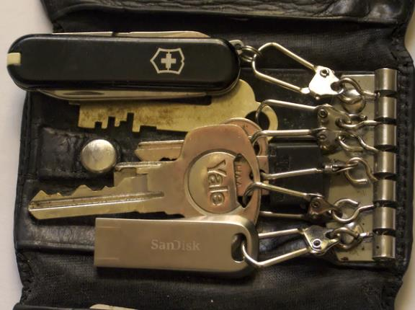
Figure 8. Keycase with Ventoy USB.

I have another Ventoy stick with a dozen or so PC repair tools, and since it has over 16 Gbytes free in its Ventoy partition, I could add more. Although I often use PartedMagic for PC rescue, it doesn’t do everything. Having all my tools on one stick means I have only one to take with me for troubleshooting a PC.

Ventoy also makes it easy to experiment with various Linux distributions. You need only download the ISO file and copy it to a Ventoy stick to try a new one. When you are through, reboot to return to the menu of Figure 1, where you can select another. Of course, there are limitations with this approach; you can’t install additional software on the distributions, and a memory stick is slower than a hard disk. Neither is particularly important when you’re just trying out a distribution to see if it’s compatible with your PC or if you like its interface. Of course, running it on a virtual machine or as a dual boot is far more preferable if you regularly use a distribution.

